

**Learning how to Edit Videos Using OpenShot**

**Prepared by Logan Vance for Code for Nepal**

**Table of Contents**

**Icon Guide………………………………………………………………3**

**Definitions for Editing Terms…………………………………….….3**

**Introduction……………………………………………………….…….4**

**Step 1: Download OpenShot………………………………………...5**

**Step 2: Save a Video File to your Computer………………...........6**

**Step 3: Open OpenShot……………………………………………….7**

**Step 4: Import your Video to OpenShot……………………………8**

**Step 5: Move your Video onto a Track……………………………..8**

**Step 6: Edit your Video Project………………………………………9**

**Step 7: Save your Video……………………………………………….10**

**Step 8: Export your Video……………………………………………..10**

**Step 9: Playback your Video…………………………………………..11**

**Icon Guide**



Imports a video file into OpenShot.



Cuts one clip into two separate clips where the marker is located.



Saves the video file.



Exports the video file.

**Definitions for Editing Terms**

**Video Editing** – the process of changing aspects of a video to make it different from what it initially was, normally to improve the viewing quality.

**Import** – bringing in an outside resource. In this case, this is bringing in a video file not currently in the program to edit.

**Clip** – a specific section of a video.

**Export** – sending something outside of its current environment. In this case, sending the edited video file to a new completed file outside of the program.

**Playback** – watching a video again, normally to see if there are any errors.

**Introduction**

OpenShot is a free video editing software that you can download on Linux, Mac, and Windows computers. Its main appeal is being easy to use for people who are just beginning to learn about video editing, but don’t want to pay for editing software such as Camtasia or Adobe Premier Pro. This will allow you to learn more about the competency of Creation and Scholarship, as recording and editing videos will allow you to create a new product. As you continue to create videos, you will hone your skills and be able to create more complex media for others to enjoy.

**Step 1: Download OpenShot**

To download OpenShot, go to the following website: <https://www.openshot.org> (this should be the first option that appears after looking up “OpenShot” on any web browser).

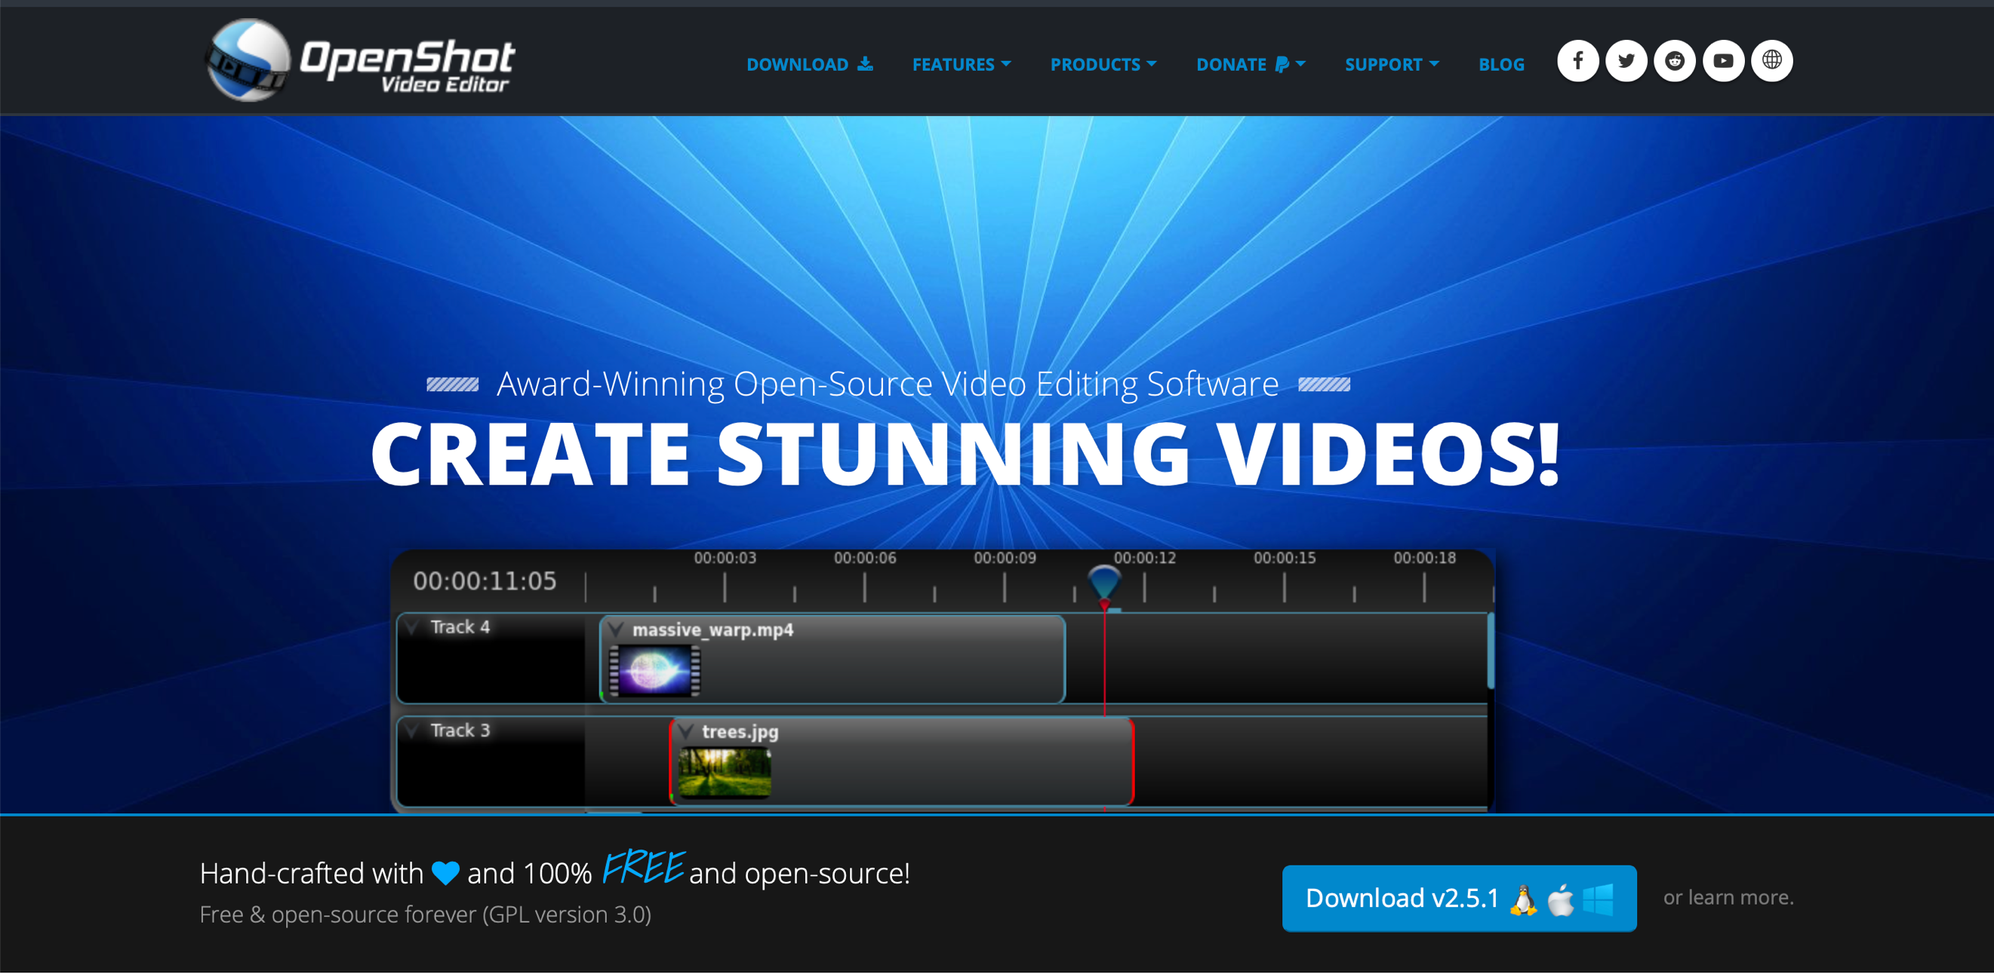

*Figure 1: The OpenShot Website. Click the download button in the bottom right corner to start the download.*

Check to make sure you’re at the same website as shown in Figure 1. Once you’re at the OpenShot website, click the blue button that says “Download” (outlined in red in Figure 1) followed by the current version of OpenShot.

Clicking on this will bring you to a new page similar to the one seen in Figure 2. This page will have a download button that looks similar to the one on the previous page (outlined in red in Figure 2). Click this to begin downloading the software.

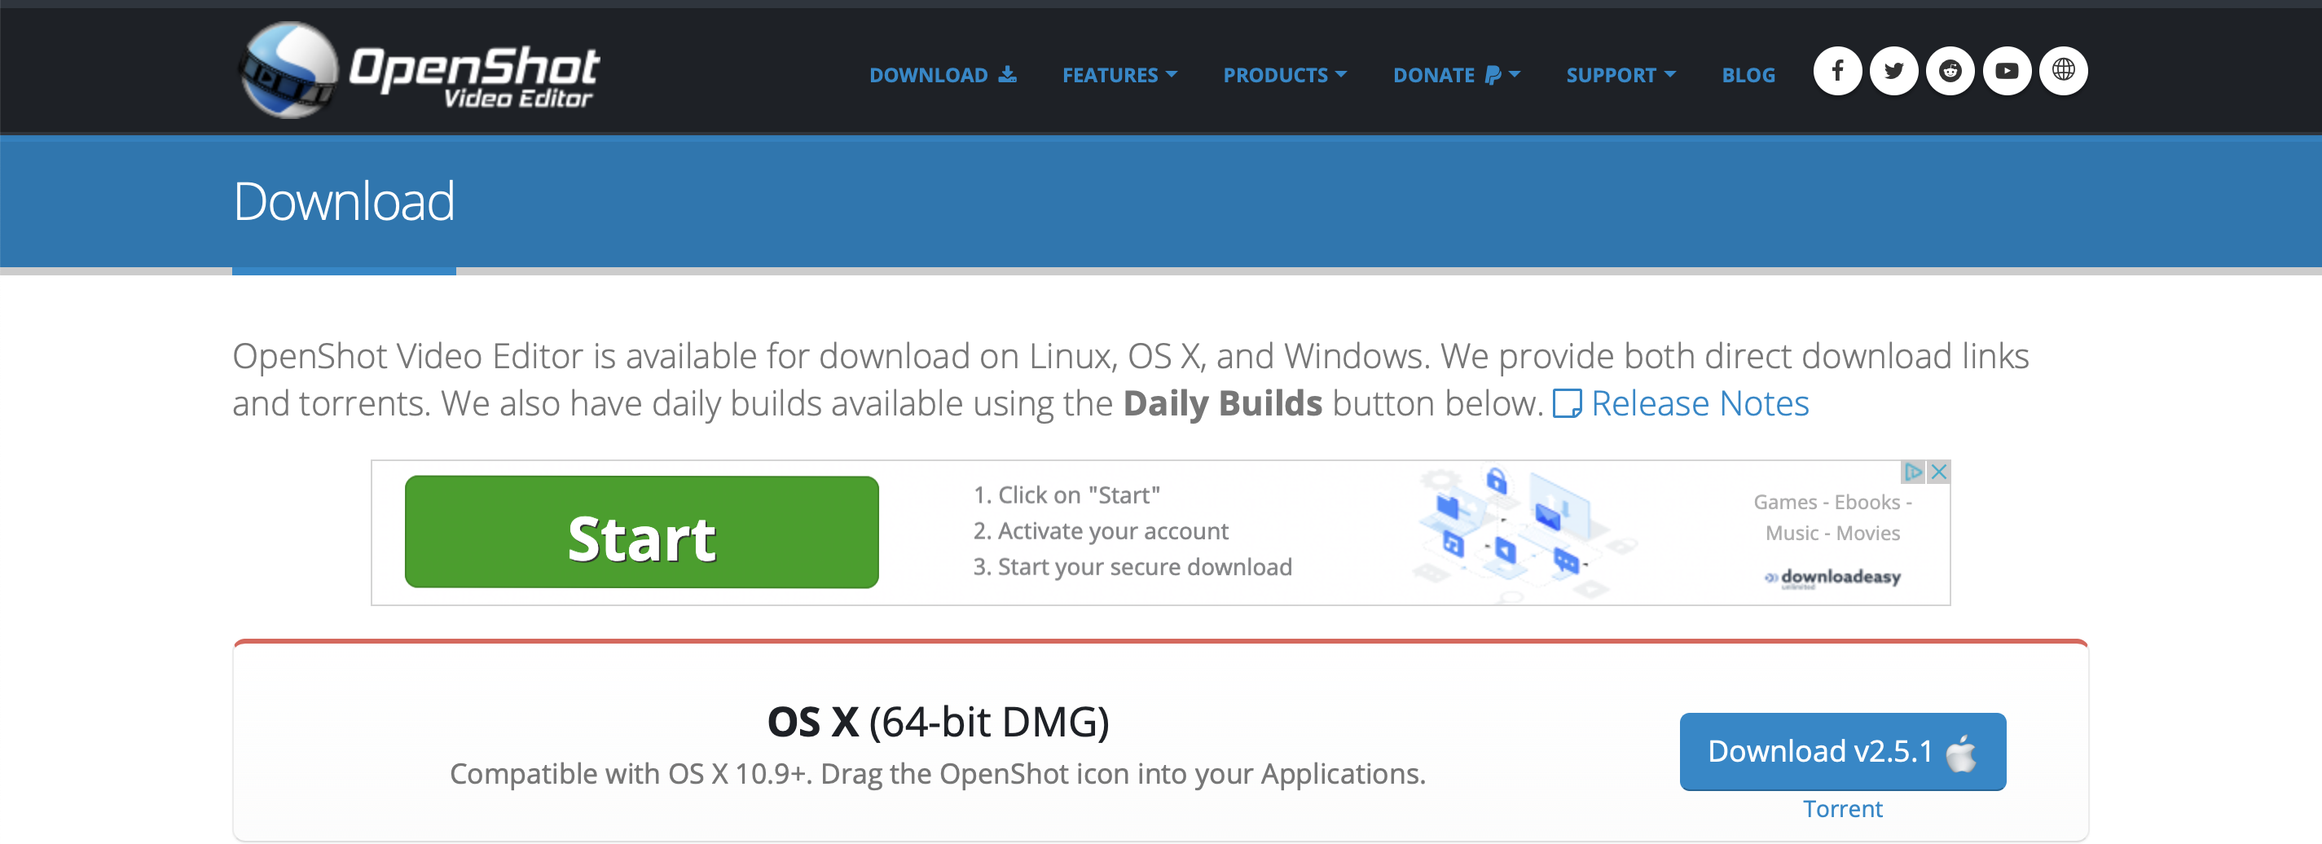

*Figure 2: The OpenShot Website after clicking the download button. Click the download button in the bottom right corner to continue the download.*

After the download is complete, click the OpenShot icon where downloads appear in your browser (on Windows, this should be in the bottom left of the page). This will open up a window that will allow you to move OpenShot into your Applications, similar to the one seen in Figure 3.

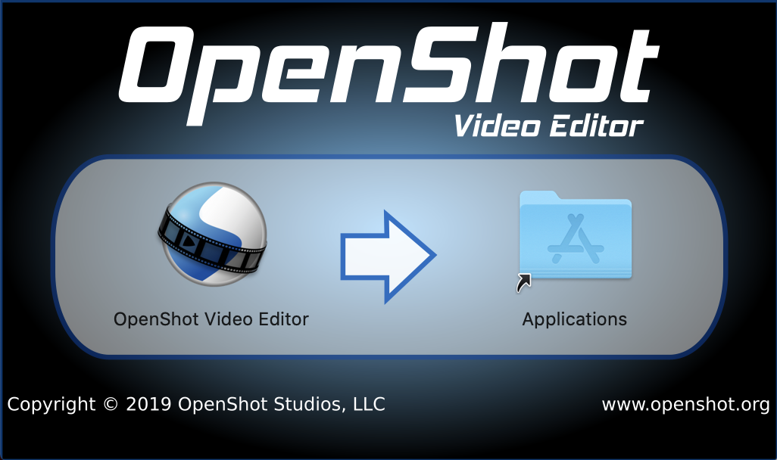

*Figure 3: Move the “OpenShot Video Editor” program to the “Applications” folder.*

**Step 2: Save a Video File to your Computer**

Before you begin with OpenShot, you’ll need to save at least one video file to your computer to edit with. How you do this will vary depending on what operating system you will be using, but this is an overview for how you can save video files on most operating systems.

The easiest way to get video footage to use, either for practice or for a full project, is to record the video on your phone and transfer it over to your computer. Select the camera app on your smartphone. It should also have an option to switch to taking videos, similar to Figure 4.

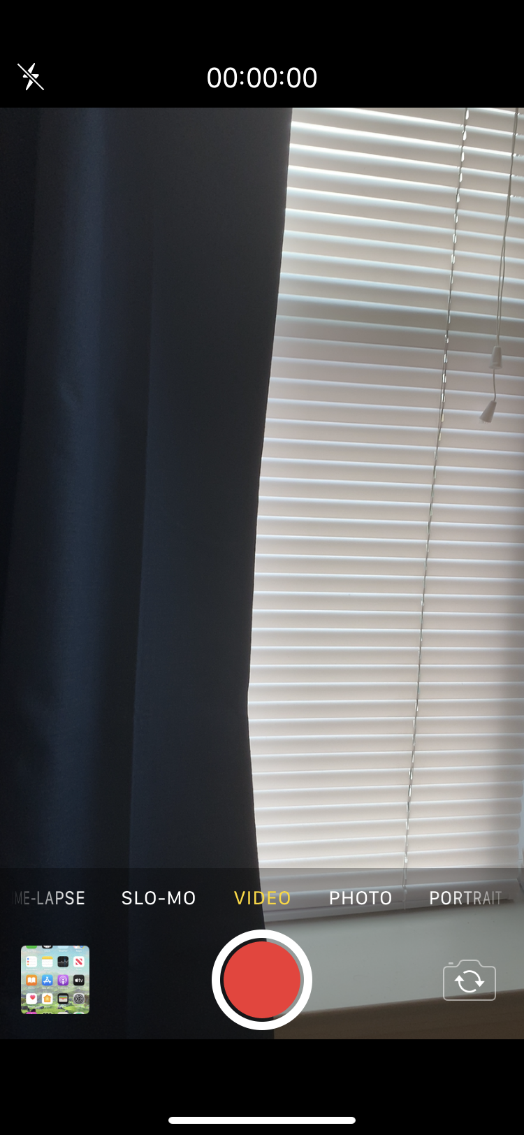

*Figure 4: The camera app on a smartphone, switched to the setting to record videos.*

Click the record button to begin recording and click it again to stop recording. This should save a video on your phone, located in the same place where photos are saved.

Now it is time to move the video to your computer. There are several ways to do this, and again it varies greatly depending on your operating system, but here are two methods that should work across most platforms:

**Plugging your Phone into your Computer:** Most phones have the option to plug a phone directly into your computer. Once you do this, your computer should open up a window for data on your phone and available actions. One of these actions should allow you to transfer files. Be sure to save the video you just took to a convenient location on your computer.

**Email Yourself the Video:** If you have a stable internet connection, you should be able to attach the video file to an email and email yourself the video. You can then open your email on your computer and save the file to your system.

**Step 3: Open OpenShot**

Go to your Applications folder and find the “OpenShot Video Editor” program. Click on the icon to open OpenShot. You should be brought to a screen similar to Figure 5.

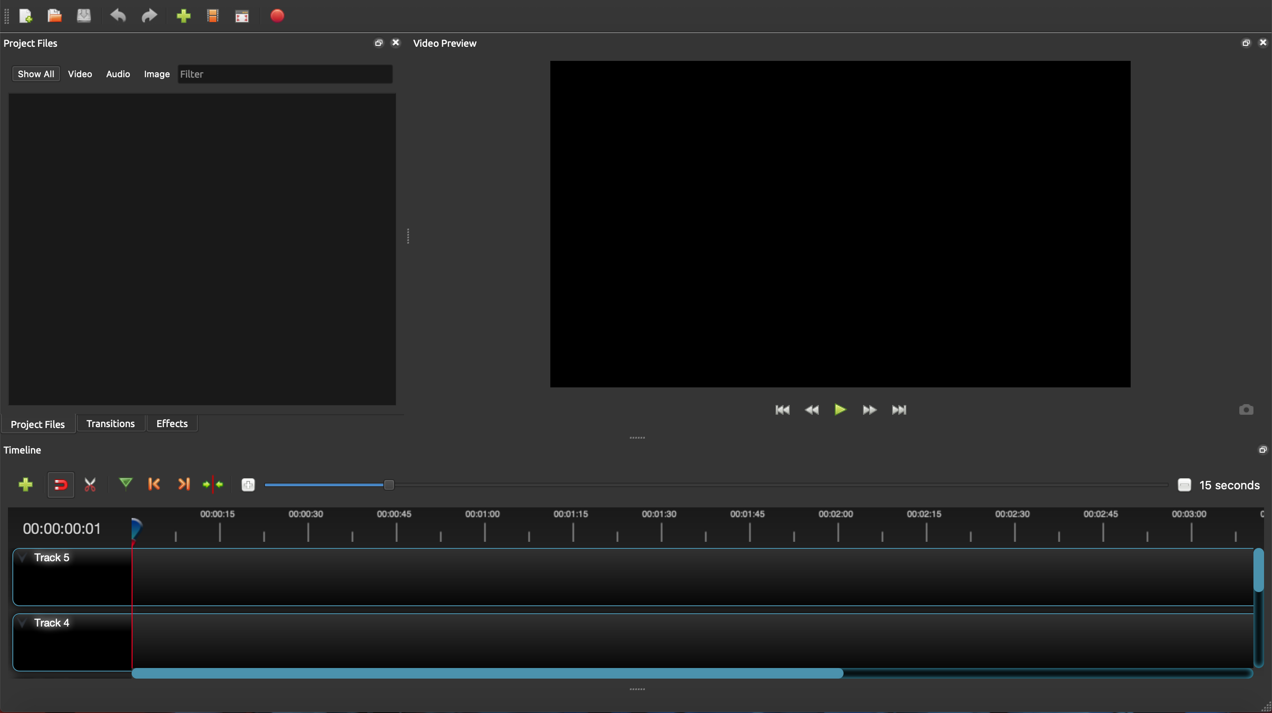

*Figure 5: The OpenShot program. This is how it will appear the first time you open it.*

**Step 4: Import your Video to OpenShot**

There are several ways to import the video recorded into OpenShot:

* Click the green plus arrow (see Icon Guide, also outlined in red in Figure 5) at the top of the OpenShot window. Then select the file you saved that you would like to edit.
* Click “File” at the top of the screen, and then click the “Import Files” option. Select the file you saved that you would like to edit. (Note: the “File” option is located in slightly different places for different operating systems, but should always be near the top of the screen.)
* Find the video file you saved that you wished to edit and drag the file into the “Project Files” box on the left of the screen (outlined in yellow in Figure 5).

Once you have moved the file into OpenShot, you should be able to see the video file in the “Project Files” section of OpenShot (outlined in red in Figure 6).

**Step 5: Move your Video onto a Track**

Drag the video file from the “Project Files” section (outlined in red in Figure 6) and place it onto one of the tracks in the lower part of the window (outlined in yellow in Figure 6). This will add your video to the actual project, allowing you to see the duration of the video in the lower area, as well as the video itself in the preview screen (outlined in orange in Figure 6).

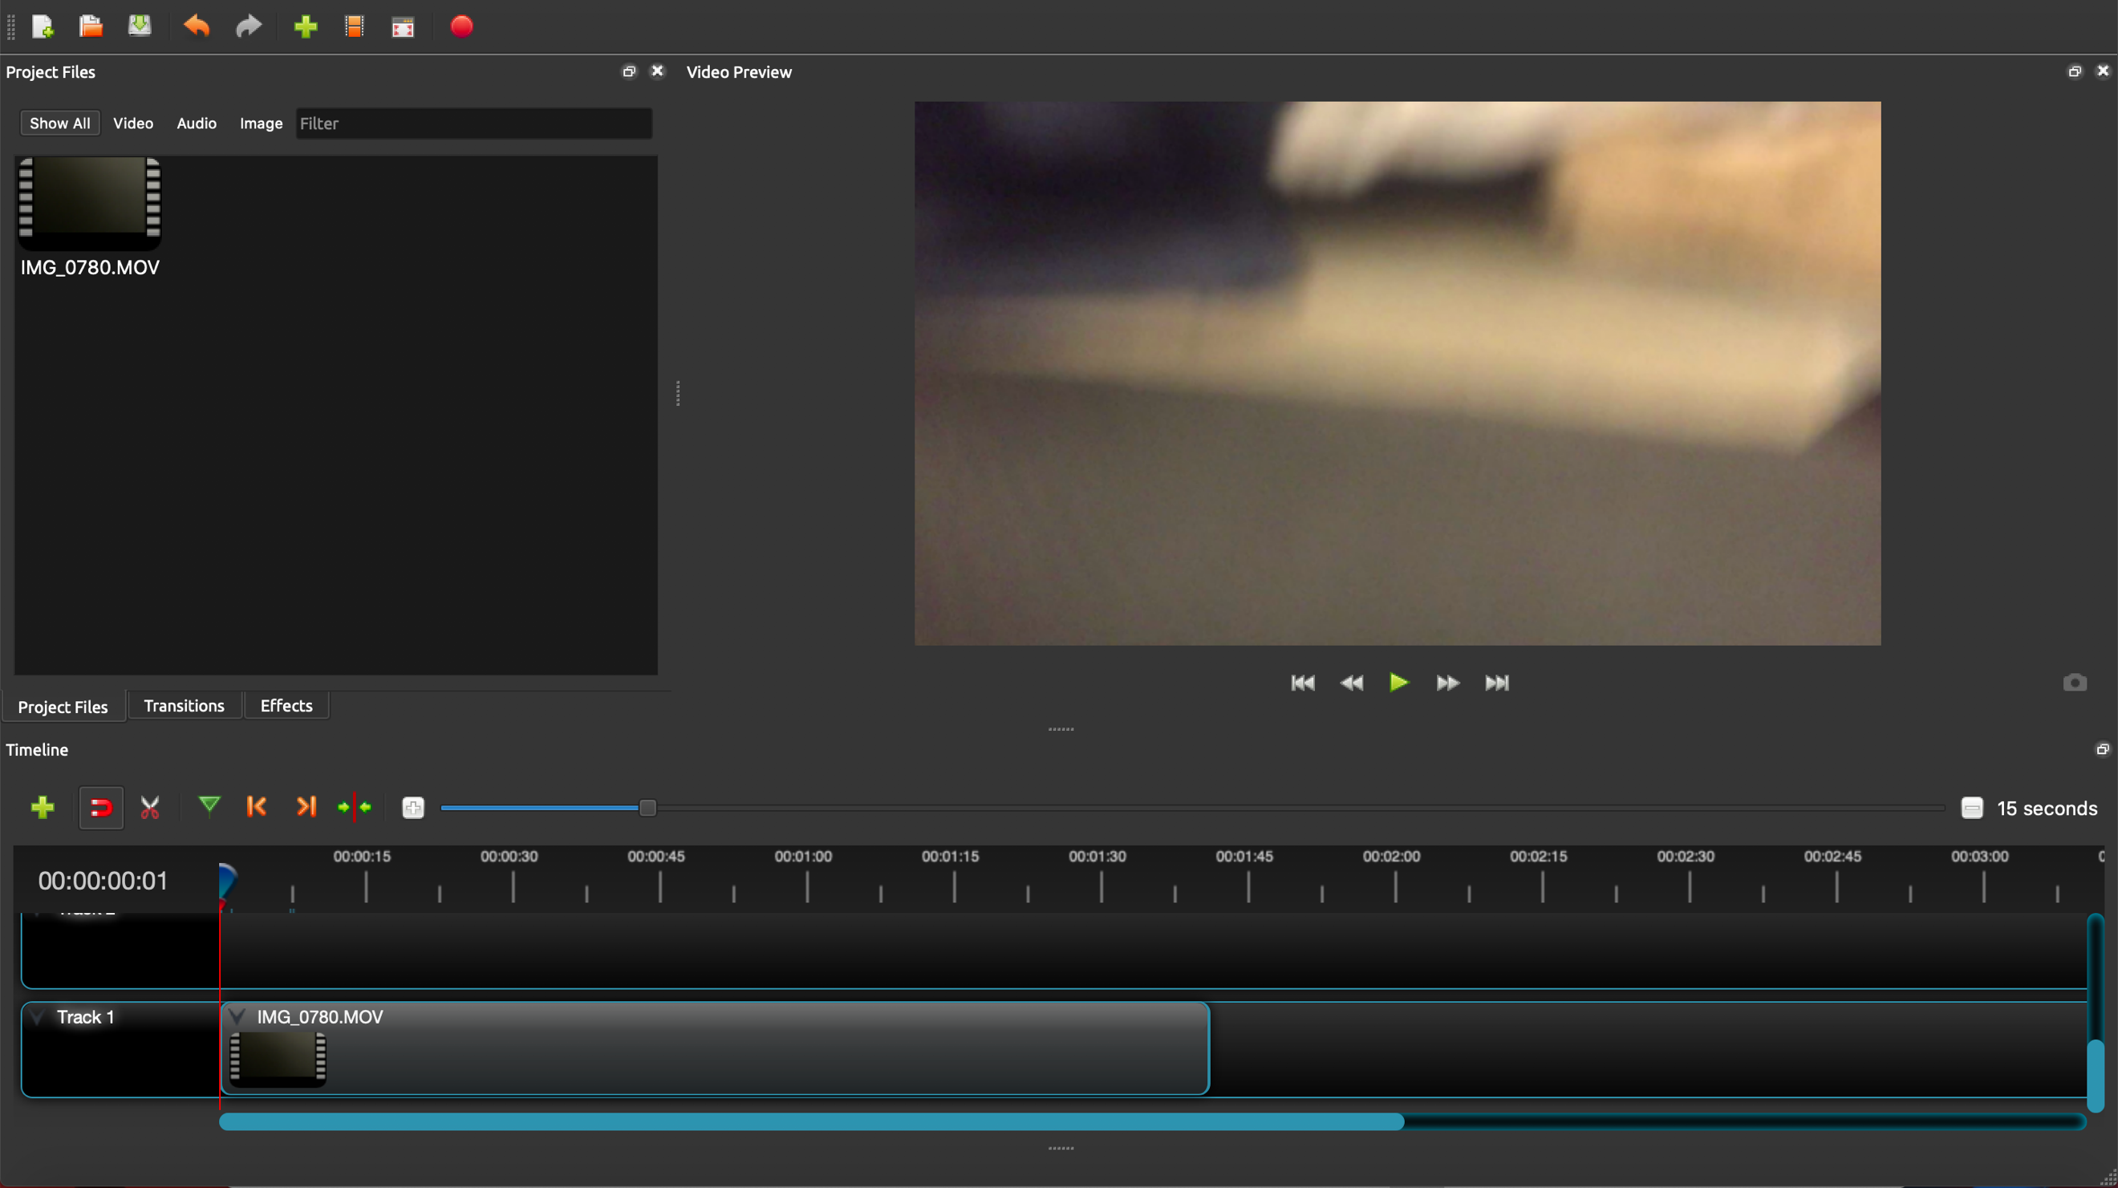

*Figure 6: The OpenShot video editor after importing a video file.*

You can also add in other videos (or images) on the tracks. Placing one on the same track after the video already placed there will cause it to play right after the current video is finished. Placing it on another track will cause the two videos to play at the same time.

Whichever video is on the higher numbered track will be shown over the video on a lower track (so a video on Track 5 will play over a video on Track 4). However, audio will still play on from both tracks, so make sure you have the volume on your computer on while editing to make sure the volume sounds how you want it to sound.

**Step 6: Edit your Video**

Make any edits you wish to the video. Here are some of the most common edits that can be made to a video:

* **Cutting Clips:** Click on the scissor icon (see Icon Guide, also outlined in red in Figure 7) and then click on the place in the clip you want to cut it in order to cut the clip into two. This can be seen in the track, with each clip now being it’s own rectangle (outlined in yellow in Figure 7).
* **Shortening Clips:** If you hover your mouse over the end or beginning of a clip in the track, a double-sided arrow will appear. Drag your mouse to cut out either the end or beginning of a clip. In the track, the clips will now be shorter (outlined in yellow in Figure 7).
* **Fade In and Fade Out:** Right click on the clip, and then select the “Fade” option. This will allow you to add a “Fade In” to the beginning of the clip, or a “Fade Out” to the end of the clip. This is indicated on the track with small green marks where the clip will finish the Fade In or start the Fade Out (outlined in yellow in Figure 7).

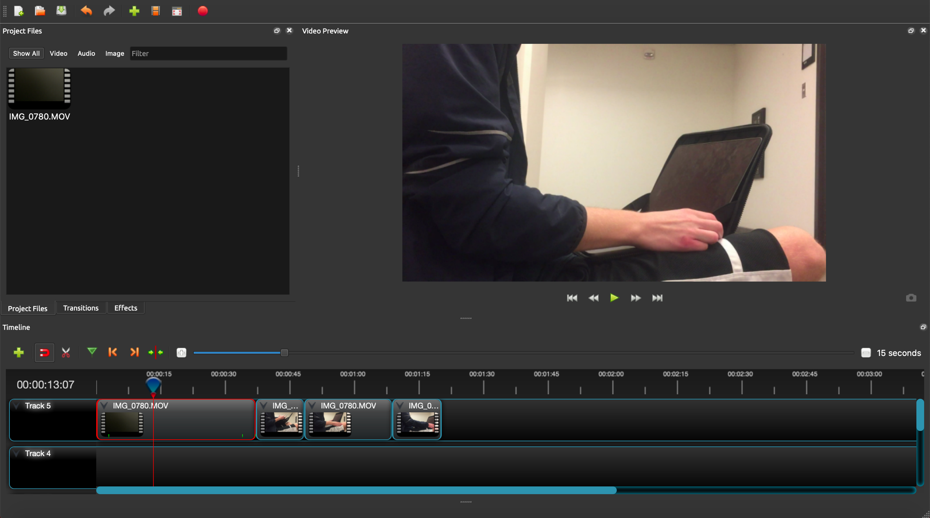

*Figure 7: Shows OpenShot, now with an edited video.*

You can also edit the audio of the clip. Right click on the clip and select the “Volume” option from the menu, and then select the “Entire Clip” option. From this menu you are able to Fade In and Fade Out audio the same way you can with video. You can also adjust the volume of the clip, taking it to a lower percentage if you want to lower the volume. To mute the audio for a clip, select the “Volume 0%” option.

**Step 7: Save your Video Project**

To save the video project, click on “File” menu at the top of the screen and select the “Save Project As” option. You can also click the save icon (see Icon Guide, also outlined in orange in Figure 7) at the top of the OpenShot window. (Note: the “File” option is located in slightly different places for different operating systems, but should always be near the top of the screen.)

**Step 8: Export your Video**

To export the video, click on the “File” menu at the top of the screen and select the “Export Project” and then the “Export Video” options. You can also click the export icon (see Icon Guide, also outlined in green in Figure 7) at the top of the OpenShot window.

A new “Export Video” window will then open, similar to the one in Figure 8. (Note: the “File” option is located in slightly different places for different operating systems, but should always be near the top of the screen.)

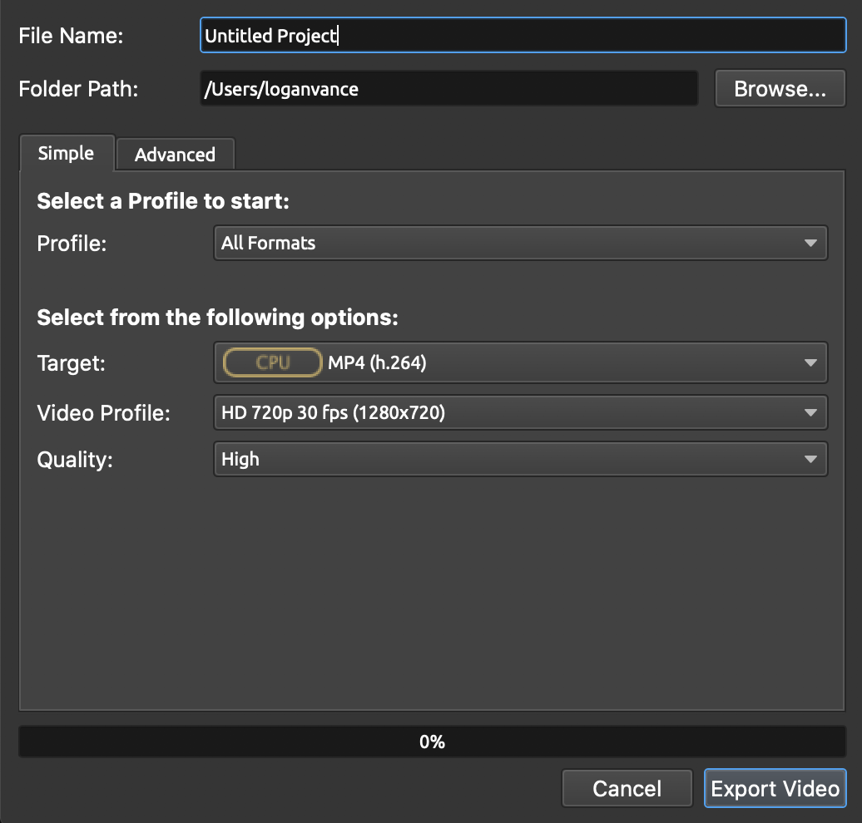

*Figure 8: The export menu within OpenShot.*

This will allow you to choose the file name and location of your video. It will also allow you to select various format and quality setting for the video.

It is usually good to save the video as an MP4, as that’s the most common video file many phones and computers can play. The default Video Profile and Quality (HD 720p 30fps and High, respectively) will produce a high-quality video that shouldn’t take too long to export. Finally, click the “Export Video” button (outlined in red in Figure 8) and wait for the video to finish exporting.

**Step 9: Playback your Video**

Go to the location you saved your video. Open the file and playback your video to ensure all of the edits were made correctly. Now, you should be able to send your video to others or upload it on websites such as YouTube for others to enjoy.